

**Experimental Lab Student Report**

Week 7 Lab

Lab Title: Operating System Management and Networking

Student Name: Anthony Meunier

Date: 2/19/2014

After completing the activities, take a screenshot of the following and copy onto this report:

1. Activity 10-1, after #5 – showing the IRQs (6 points)

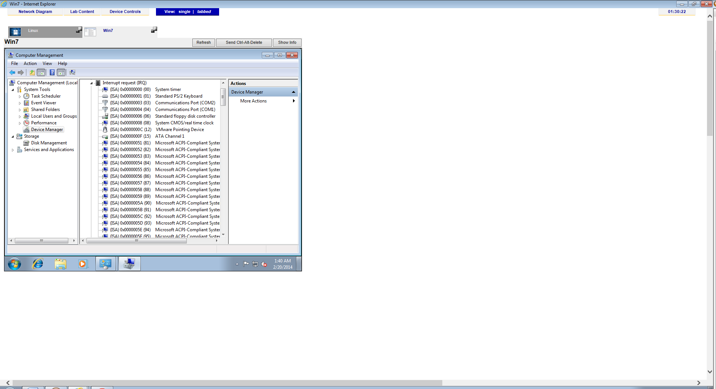

1. Activity 10-3, after #4 (6 points)

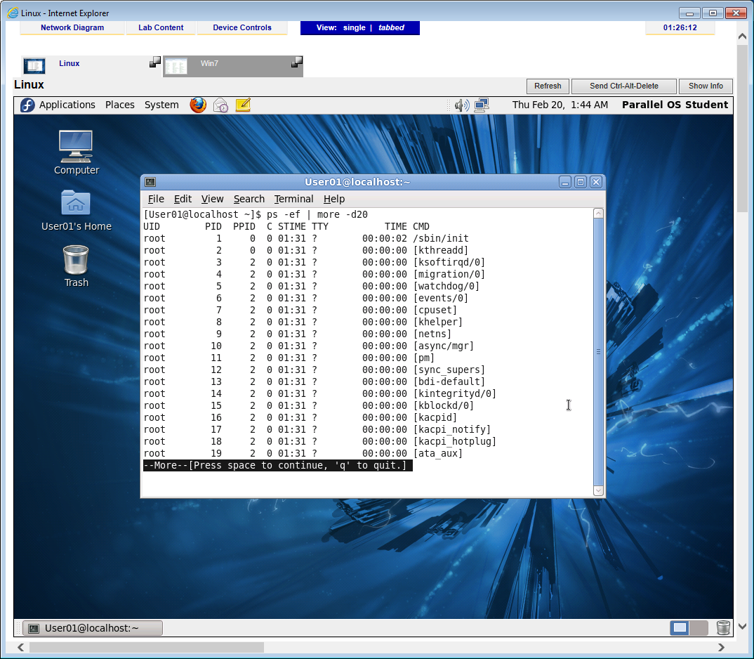

1. Activity 10-4, after #4. (6 points)

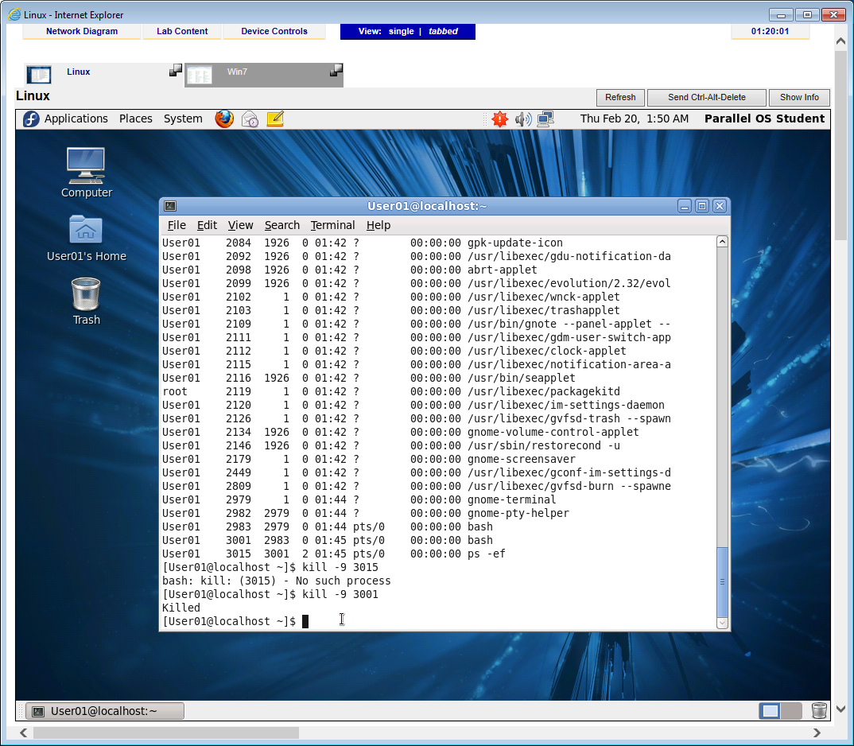

1. Activity 10-7, after #8 (6 points)

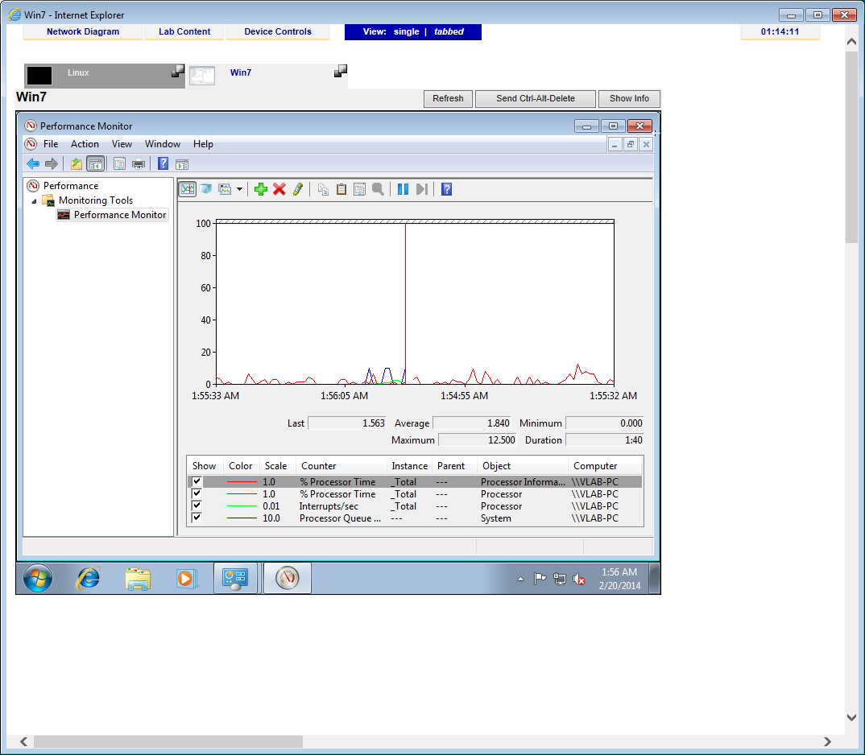

1. Activity 11-1, after #3 (6 points)

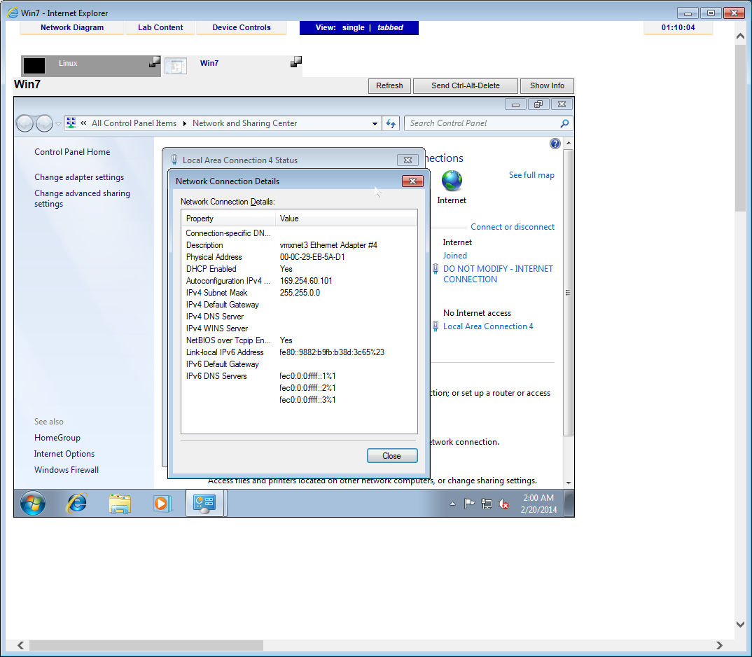

1. Activity 11-1, after #7 but expand command window to fill screen vertically (6 points)

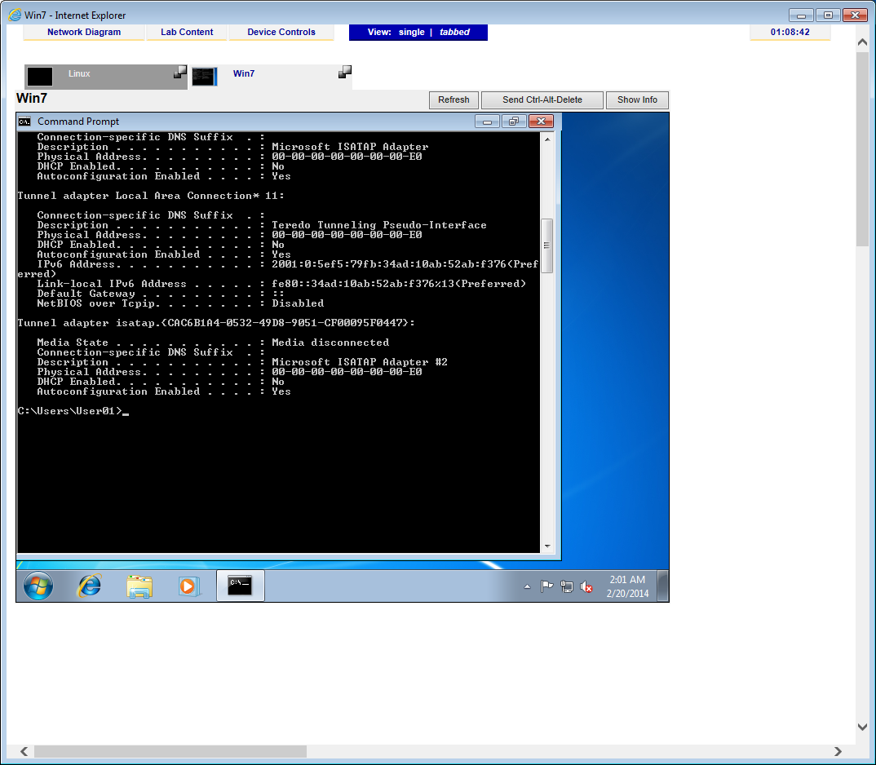

1. Activity 11-2, after #5 (expand terminal window to see everything) (7 points)

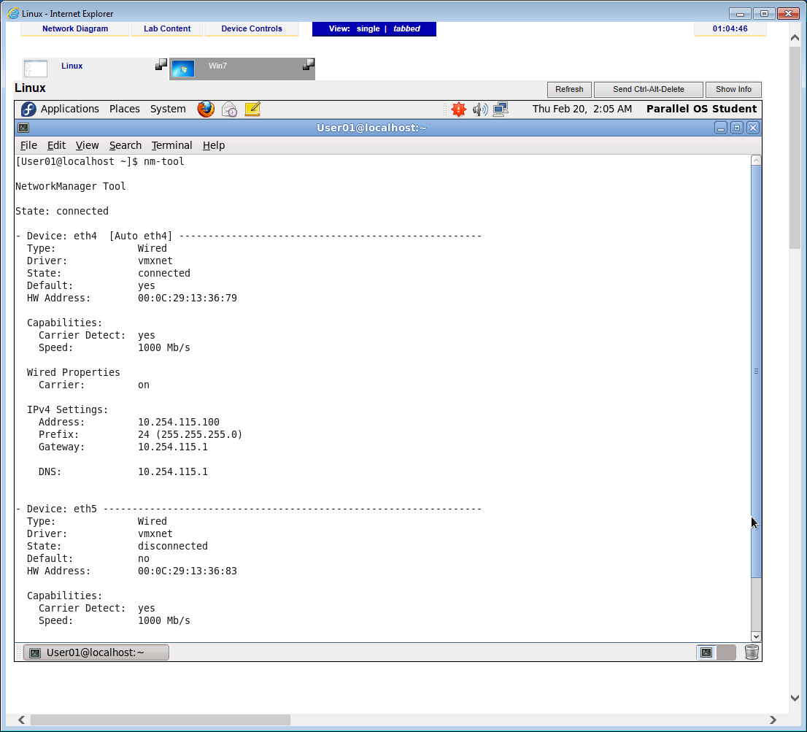

1. Activity 11-2, after #7 (7 points)

